Software Engineering Concpets:
- Network:
i) Sockets (enables communication between different processes)
def.:
- Sockets are an abstraction provided by operating systems to enable communication between different processes/server either by the same machine or over a network. They act as endpoints in a two-way communication channel
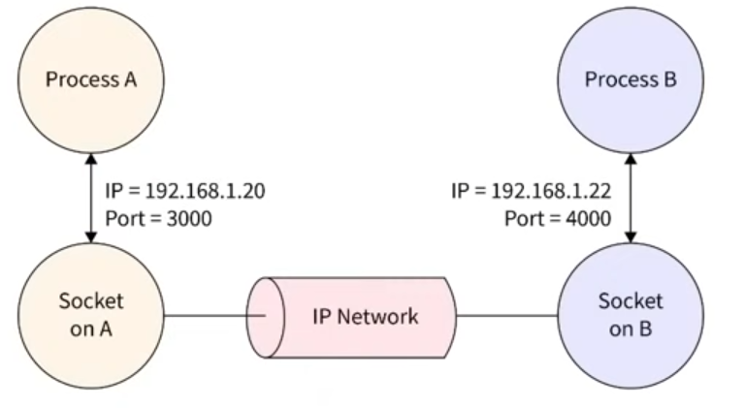
so when two machines or two applications need to talk to each other over the internet or a local network, each side of that communication will create a socket

- A socket is an OS-managed communication endpoint that represents a stream of bytes between applications.
Applications do not communicate directly with the network. Instead, they communicate through sockets provided by the operating system.
A socket provides a simple interface: send(bytes)
receive(bytes)
A socket is identified by: IP Address + Port Number + Protocol
This does NOT mean the socket is those things.
-> Rather, the OS uses this information to find the correct communication endpoint.
IP Address = Which machine?
Port= Which application/service on that machine?
Protocol (TCP, UDP) = How should communication behave?
A TCP socket typically stores: Local IP, Local Port, Remote IP, Remote Port, Protocol
Send Buffer, Receive Buffer, Connection State
99% of Developers Don't Get Sockets

Sockets in the OSI Model
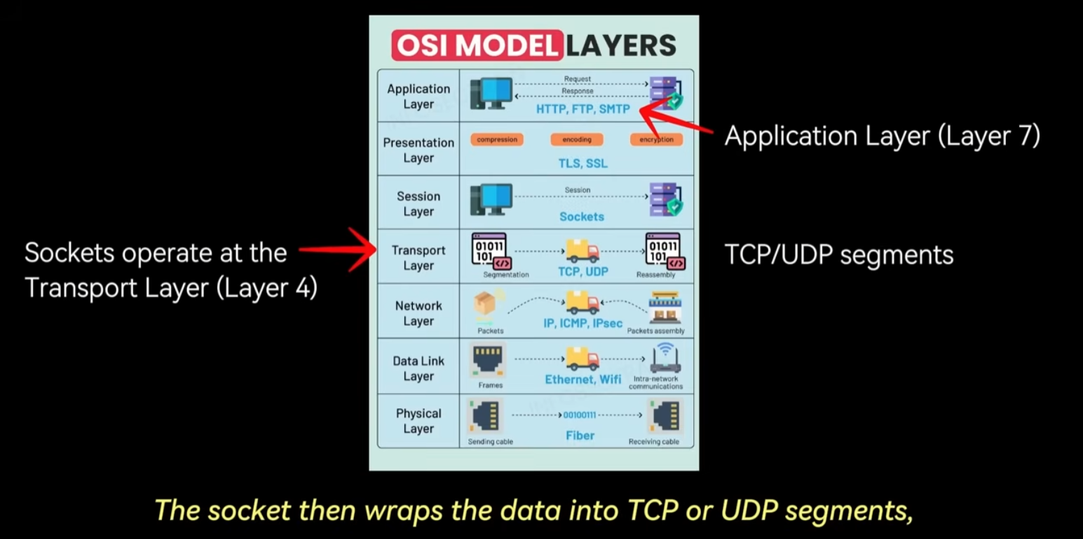
Sockets operate primarily at the Transport Layer (Layer 4) of the OSI model.
The Application Layer (Layer 7) (e.g., a web browser or backend service) uses the socket API to send and receive data.
The socket then packages the data into TCP or UDP segments, adds the necessary headers, and passes it to the Network Layer (Layer 3), which handles IP routing.
Sockets therefore provide a clean interface between application logic and the underlying network stack, shielding developers from details such as:
- Routing
- Packet fragmentation
- Retransmission
- Other low-level networking complexities

Types of Sockets
TCP Sockets (Transmission Control Protocol)
TCP sockets are connection-oriented and provide:
- Reliable transmission
- Ordered delivery
- Error checking

Before communication begins, TCP performs a three-way handshake using SYN and ACK packets to establish a connection and ensure both sides are ready.
TCP guarantees that packets:
- Arrive
- Arrive in order
- Are not duplicated
This makes TCP suitable for:
- Web browsing
- Database access
- File transfers

UDP Sockets (User Datagram Protocol)
UDP sockets are connectionless and unreliable.
They send datagrams directly to a target IP address and port without a handshake.
UDP provides no guarantee of:
- Delivery
- Ordering
- Integrity
However, it is much faster and more lightweight than TCP.
This makes UDP suitable for:
- Video streaming
- Other real-time applications where speed is more important than reliability

Server-Side Socket Lifecycle
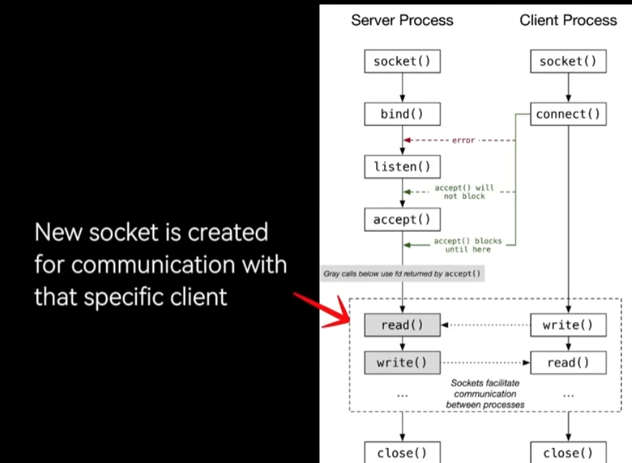

- The server creates a listening socket.
- The listening socket is bound to a specific IP address and port.
- The listening socket waits for incoming client connections.
- When a client connects, the server accepts the connection.
- A new socket is created for that specific client.
- The original listening socket continues listening for additional clients.
The newly created socket becomes the communication channel for that client.
This allows a server to handle many clients concurrently, each with its own dedicated socket.

Client-Side Socket Lifecycle
- The client creates a socket.
- The client connects to the server's IP address and port.
- For TCP, this initiates the three-way handshake.
- Once connected, the client can read from and write to the socket.
From the application's perspective, a socket behaves similarly to a file.

After communication ends, both the client and server should close their sockets.
This:
- Frees system resources
- Prevents memory/resource leaks
Improperly closed sockets can cause resource exhaustion, especially on busy servers.

ii) Port
def.:
- A port is a logical communication address for an application on a machine.
idea: computer runs many programs at the same time — browser, Spotify, Discord, your Python server. All of them can receive data from the network. But when a packet arrives at your computer, how does Windows know which program it belongs to? That's what ports solve.
Example: 192.168.1.20:5000
192.168.1.20 = machine
5000 = application (port number)
Key facts
- Port numbers go from 0 to 65535
- Ports 0–1023 are reserved for standard services (80 = HTTP, 443 = HTTPS, 22 = SSH)
- Ports 1024–65535 are free to use for your own programs
- Two programs cannot share the same port — if your server is already running on 12345, nothing else can use 12345 at the same time

iii) TCP (Transmission Control Protocol)
- TCP is a transport-layer protocol that establishes a reliable, ordered, bidirectional byte stream between two applications running on different machines.

Protocol= set of rules that both “sides” agree to follow
TCP defines rules for:
- establishing a connection
- numbering data
- acknowledgements (ACKs)
- retransmissions
- closing connections
- flow control

- TCP guarantees: If data is lots. TCP retransmits it
Data arrives ordered (same order as it was sent)
- TCP is a byte stream; it doesn’t think in/respect packages.
So it is a reliable ordered byte pipe between the server application and the client application
- TCP =! TCP Socket
A TCP socket is an OS object that uses TCP. So TCP defines how communication work and a TCP socket uses TCP to communicate
So A socket that uses TCP as its transport protocol is called a TCP socket

PROJECT
- NETWORK.
  - Server generates EMG samples.

  - Every ~9 ms it accumulates 18 new samples for each of the 32 channels.

  - These are packed into one logical packet of 4608 bytes.

  - The server writes those bytes to its TCP socket.

  - TCP treats the data as a continuous byte stream and transmits it over the network.

  - The OS/network may split, merge, or segment the bytes arbitrarily during transmission.

  - On the client side, incoming bytes are placed into the socket receive buffer managed by the OS.

  - Every 50 ms the Qt timer calls recv().

  - recv() retrieves whatever bytes are currently available in the socket buffer.

  - Because TCP is a stream protocol, recv() may return partial packets, complete packets, or multiple packets at once.

  - Therefore, the client maintains its own byte buffer and reconstructs the original 4608-byte packets before converting them into a (32 × 18) float64 NumPy array.
Understanding the Code Base:
Script: tcp_client_model.py

Short Overview:
The TcpClientModel class is a TCP client that receives streaming EMG signal data from a server and maintains a rolling buffer for plotting

Structure at a glance:
TcpClientModel
│
├── __init__() — Configuration & state setup
│
├── Connection management
│ ├── connect() — Opens TCP socket (non-blocking)
│ └── disconnect() — Closes socket
│
├── Data reception
│ ├── receive_data() — Reads raw bytes from socket
│ └── _extract_packets_from_buffer() — Parses bytes → NumPy arrays
│
└── Data access
├── has_data() — Checks if enough data exists to plot
├── get_window() — Returns (x, y) for the current plot window
└── get_signal_time_seconds() — Returns total elapsed signal time

Concept | Detail
Protocol | Raw TCP byte stream — data is float64 NumPy arrays serialized with .tobytes()
Packet format | 32 channels × 18 samples → reshaped to (32, 18) per packet
Rolling buffer | Keeps only the last N seconds (default: 10 s) of data
Non-blocking socket | recv() won't freeze the GUI; BlockingIOError is the normal "no more data" signal
Byte buffer | Accumulates raw bytes until a full packet is assembled (handles TCP fragmentation)

Questions:
  - What are NumPy arrays?
- a NumPy array is a grid of numbers stored efficiently in memory. Like a python list but:
- All values are the same type (e.g. all float64)
- Can be 1D (a row), 2D (a table), 3D (a cube)
- Math operations work on the whole array at once
Ex.
1D: [0.003, -0.001, 0.007, 0.002] ← one channel's signal
2D: [[0.003, -0.001], ← channel 1
[0.007, 0.002]] ← channel 2

[Difference between python list and NumPy array?
Use python list when: You store arbitrary objects
You append/remove items frequently (=size changes freq)
The data is not primarily numerical (mix of int, float., str.)
Use NumPy array when: Data represents measurements
Data represents vectors/matrices
You perform mathematical operations
You work with signals, images, ML, FFT, statistics]

- what is float64 and .tobytes()?
- float64 = a decimal number stored in exactly 8 bytes (64 bits). The "64" is the number of bits, not decimal places. It gives you about 15 significant digits of precision (e.g. 0.003421567891234).
- .tobytes() = the server takes its numpy array of numbers and converts it into a raw sequence of bytes for sending over TCP. Like flattening a spreadsheet into a long string of 0s and 1s.
Reverse: np.frombuffer(…) = You take the raw bytes you received and convert them back into a numpy array of float64 numbers

- Non-blocking socket- why does blocking matter?
- Blocking = recv() waits forever until data arrives. If no data comes for 2 seconds, your entire program freezes for 2 seconds. The GUI stops responding. Buttons don't work. The plot stops updating
- Non-Blocking = recv() checks instantly. If data is there-> returns it. If no data-> immediately raises BlokcingIOError instead of waiting. Program keeps running normally
BlokcingIOError = is not a real error. It means "no bytes available right now." The program catches it and moves on immediately.

- How can the program run without data?
The app is driven by the Qt event loop, which runs continuously regardless of TCP data. The QTimer fires receive_data() every 50ms.
That function:
- Checks the socket instantly (non-blocking)
- If no data → catches BlockingIOError→ returns immediately → Qt keeps running
- If data → processes it → returns → Qt keeps running
The program never waits. It just checks and moves on.

- Note:
The QTimer is not connected to buttons. They are independent.
QTimer → controls data flow (receive + plot update) runs automatically, no user interaction needed
Buttons → control app state (connect, disconnect, channel, mode) user triggers these manually

User clicks Connect button:
→ ViewModel calls model.connect(port)
→ ViewModel STARTS the QTimer ← this is the only connection
→ QTimer now fires every 50ms

User clicks Disconnect button:
→ ViewModel calls model.disconnect()
→ ViewModel STOPS the QTimer
→ No more receive_data() calls

- What is displayed when there is no new data ?
The plot always shows **whatever is currently in the data_buffer**:
- Buffer empty → blank plot or "waiting" message
- Buffer partially filled → shows however many seconds have arrived
- Buffer full, no new data → plot freezes on last known state
- Disconnected → buffer frozen, plot stays showing last 10 seconds (offline inspection)

- Channel switching with no new data
When the user switches to channel 3, `get_data(channel=3)` just reads a different row from the existing buffer. It works instantly regardless of whether new data is arriving.

- How the rolling plot moves:
- New data enters from the **right**
- Old data is cut from the **left**
- The signal appears to scroll left on screen, like a hospital ECG monitor
- The right edge always represents "now"

- The x-axis:
- The **width** is always fixed at 10 seconds
- The **labels** (timestamps) shift forward with every update
- Example: at t=12s into the stream, x-axis shows 2s → 12s
- x is recalculated each time from total_samples_received / sampling_rate
- With every new packet, x shifts forward by 18 × 0.5ms = 9ms

- Rolling Buffer
- This is just: how many numbers do you need to store to have exactly 10 seconds of history?

samples to store = sampling rate × seconds = 2000 × 10 = 20000

So, the data_buffer keeps a maximum of 20,000 columns. When column 20,001 arrives, column 1 is deleted. The buffer size is always ≤ 20,000. That's it

- What does disconnect() release?
- It releases the socket — meaning:
- The TCP connection to the server is closed
- The OS frees the socket's buffer
- Windows stops routing incoming bytes to your program
- No more bytes can arrive
The data_buffer (your numpy array) is not released — it stays in memory so you can inspect the recorded signal offline

- Does each channel have its own rolling buffer?
No, There is one data_buffer for all 32 channels together. It is a single 2D numpy array:
data_buffer.shape == (32, 20000)

Row 0 = all samples for channel 1 → [0.003, -0.001, 0.007, ..., 0.002] 20000 values
Row 1 = all samples for channel 2 → [-0.001, 0.002, 0.003, ..., 0.001] 20000 values
...
Row 31 = all samples for channel 32 → [0.007, 0.001, 0.002, ..., 0.003] 20000 values

-> when you want channel 5: data_buffer[4, :]→ gives you that one row = 20,000 values = the full 10-second signal for electrode 5.

- How does get_window() work and how does displaying the signal work?
- get_window() just returns two 1D arrays — x (time) and y (voltage values) — for one selected channel
Ex. y = data_buffer[selected_channel, :] # e.g. 20000 voltage values
x = [0.0, 0.0005, 0.001, ..., 9.999] # time in seconds (just index / 2000)

Why index / 2000 gives time
Each sample was taken 1/2000 of a second apart (because sampling rate = 2000 Hz).
So:
- Sample 0 was taken at t = 0/2000 = 0.000s
- Sample 1 was taken at t = 1/2000 = 0.0005s
- Sample 2 was taken at t = 2/2000 = 0.001s
- Sample 4000 was taken at t = 4000/2000 = 2.0s
- Sample 19999 was taken at t = 19999/2000 = 9.9995s

The frontend (VisPy) receives these two arrays and draws a line graph: x on horizontal axis, y on vertical axis. That's the signal plot.
Each channel produces its own separate signal line. You display one channel at a time (user selects which one)

Tcp_client_model.py Code Base :
- Def_init_() :
def __init__(
self,
host, # IP address of the TCP server
port, # Port number
sampling_rate, # Samples per second (e.g. 2000hz)
channels, # Number of EMG channels (e.g. 32)
samples_per_packet, # Samples per channel per packet (e.g. 18)
window_seconds, # How many seconds to show in the plot (e.g. 10)
selected_channel, # Which channel to display (e.g. 7)
):

- This are the variable values that we need to pass when initializing an object of that class:
host, port # where to connect
sampling_rate, channels # signal properties
samples_per_packet, window_seconds # packet & buffer config
selected_channel # which channel to plot

self.dtype = np.float64 #np. = class

self.socket = None
self.is_connected = False

self.packet_size = self.channels * self.samples_per_packet
self.packet_size_bytes = self.packet_size * np.dtype(self.dtype).itemsize

self.window_size = int(self.sampling_rate * self.window_seconds)

self.byte_buffer = bytearray()
self.data_buffer = np.empty((self.channels, 0), dtype=self.dtype)
self.total_samples_received = 0

- Values that are derived / initialized inside _init_

Parameters in → __init__ → derived state ready for all methods
│
┌──────────────┼──────────────────┐
dtype socket/flag buffers
(format) (connection) (byte→number pipeline)
byte_buffer → data_buffer
↑
window_size caps it

self.dtype = np.float64 | Format agreement with the server.  The server sends numbers as float64 (8 bytes each= each number occupies 8bytes and is a float).  This tells the client how to interpret the raw bytes it receives.
self.socket = None  self.is_connected = False | Connection state.  No TCP connection exists yet when the object is created.  - When you call connect(), python creates a TCP socket object that holds the connection between server and client  is_connected is a simple True/False flag used to guard all methods -> don't receive data if not connected, don't connect twice, etc.
self.packet_size = self.channels * self.samples_per_packet | Total number of float64 values in one packet.  Ex. 32 channels × 18 samples = 576 values
self.packet_size_bytes = self.packet_size * np.dtype(self.dtype).itemsize | np.dtype(...): is a type descriptor  - So it creates a descriptor object for the float64 type, and from it you can read metadata:  d = np.dtype(np.float64)  d.itemsize # → 8 "how many bytes per value?"  d.name # → 'float64' "what is the type called?"  d.byteorder # → '=' "byte order (little/big endian)?"  - .itemsize = bytes per single value  So self.packet_size_bytes  gives number of bytes in a whole packet
self.window_size = int(self.sampling_rate * self.window_seconds) | Maximum number of samples to keep in the plot buffer.  - Other samples beyond this get discarded (rolling window)
self.byte_buffer = bytearray() | Stage 1 buffer  - Collects raw bytes from the network.  TCP doesn't guarantee one recv() = one packet, so bytes accumulate here until a full packet is ready to decode. Starts empty
self.data_buffer = np.empty((self.channels, 0), dtype=self.dtype) | Stage 2 buffer (decoded EMG numbers)  - A 2D array of shape (32 channels, N samples). Starts with 0 columns (no data yet) and grows as packets are decoded from byte_buffer.  - dtype=self.dtype = every value stored in this array must be float64 (here)  When new data gets added, NumPy enforces that format
self.total_samples_received = 0 | Ever-growing counter  - Unlike data_buffer which throws away old data, this never resets. Used to calculate how long the signal has been running: total_samples / sampling_rate = seconds

- Def connect(self):
def connect(self):
"""Connect to the TCP server."""
if self.is_connected: #guard clause: if already connected, do nothing
return and exit immediatly

self.socket = socket.socket(socket.AF_INET, socket.SOCK_STREAM)
self.socket.connect((self.host, self.port))

# Non-blocking means recv() will not freeze the GUI if no data is available.
self.socket.setblocking(False) #makes the socket non-blocking

self.is_connected = True #updates the flag (init)

  - self.socket = socket.socket(socket.AF_INET, socket.SOCK_STREAM
Creates the socket object. Two arguments define what kind of socket:
- socket.AF_INET — use IPv4 addresses (e.g. "192.168.1.1")
tells socket if you want to connect to the server IP address use IPv4
IPv4 = is just the standard format for IP addresses: four numbers separated by dots
- socket.SOCK_STREAM — use TCP (stream-based, reliable, ordered)
  - self.socket.connect((self.host, self.port))
Dials the server. Sends a connection request to the IP address and port number. This is the actual TCP handshake. After this line, the connection is live.

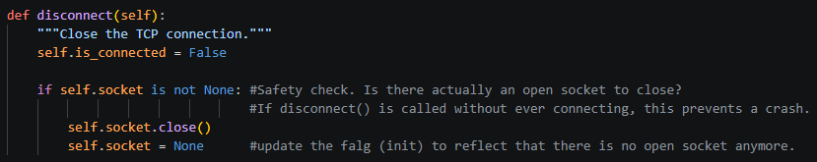
- Def disconnect():

- Def receive_data()

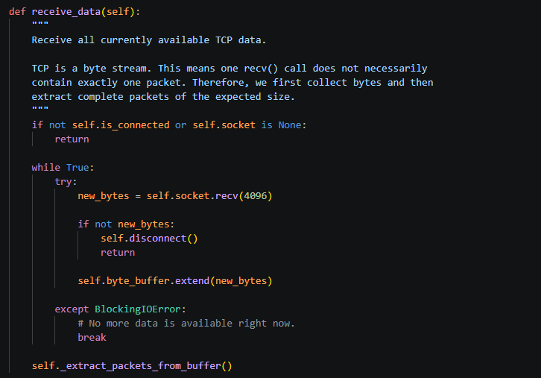

  - The loop logic:
While true runs forever-> the only way out is break or return inside:
Enter loop
↓
call recv(4096)
↓
Three possible outcomes:
├── got bytes → store → loop again
├── got b"" → server gone → disconnect → return
└── BlockingIOError → no more data → break
↓
_extract_packets_from_buffer()
The 3 outcomes of recv() in detail
Outcome 1 — Data arrived
new_bytes = self.socket.recv(4096) # returns b"\x12\x34\x56..."
self.byte_buffer.extend(new_bytes) # append to buffer
→ loop again, try to read more

Outcome 2 — Server disconnected
new_bytes = self.socket.recv(4096) # returns b"" (empty)
if not new_bytes:
self.disconnect() # clean up socket
return # exit function entirely
→ never reaches _extract_packets_from_buffer()

Outcome 3 — Connected but no data right now
new_bytes = self.socket.recv(4096) # raises BlockingIOError
except BlockingIOError:
break # exit loop normally
→ continues to _extract_packets_from_buffer()

recv() never returns b"" just because no data is available on a non-blocking socket.
When no data is available → it always raises BlockingIOError, never returns b"".
b"" (empty bytes) is a special TCP signal that only happens when the server has gracefully shut down the connection

After the loop
self._extract_packets_from_buffer()
Only reached after break (outcome 3). Takes everything collected in byte_buffer and converts complete packets into NumPy arrays. If not enough bytes for a full packet yet, it simply waits until next call

- Def _extract_packets_from_buffer(self)

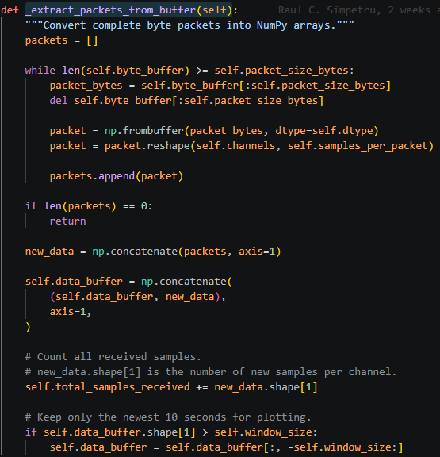

- packets is a Python list of arrays — one array per decoded packet:
packets = [
array shape (32, 18), # packet 1
array shape (32, 18), # packet 2
array shape (32, 18), # packet 3
]
- np.concatenate(..., axis=1) glues them together horizontally (along columns):
(32, 18) + (32, 18) + (32, 18) → (32, 54)
↑
3 packets × 18 samples
-> axis=1 means "join along columns" (not rows)
- self.data_buffer = self.data_buffer[:, -self.window_size:]
self.data_buffer[:, -self.window_size:]
↑ ↑
all rows last 20480 columns only
->negative indexing (cutting from the left, keeping new values from the right)
If window_size = 5 (simplified):
Columns: 0 1 2 3 4 5 6 7 8 9
[old, old, old, old, old, new, new, new, new, new]
Index: -5 -4 -3 -2 -1

-self.window_size = -5
→ start at index -5, go to the end
→ keep: [new, new, new, new, new]
Setup: Empty list to collect decoded packet arrays before merging them.

Step 1 — Extract complete packets from byte_buffer

- Keep looping as long as there are enough bytes for at least one full packet (4608 bytes).
- Slice exactly 4608 bytes from the front of byte_buffer.
- Remove those 4608 bytes from byte_buffer — they've been consumed.
- Convert the 4608 raw bytes into 576 float64 numbers. Shape is now (576,) — flat 1D array.
- Reshape from flat (576,) into (32, 18) — 32 channels × 18 samples.
- Add this packet to the list. Loop continues if more complete packets remain.

Step 2 — Early exit if nothing was decoded

- If byte_buffer had fewer than 4608 bytes, no packet was decoded. Nothing to do — exit early.
if len(packets) == 0:
return

Step 3 — Merge all new packets into one array

Glue all decoded packets together horizontally: [(32,18), (32,18), (32,18)] → (32, 54)
So np.concatenate(..., axis=1) appends new columns to the right of each row simultaneously:

Step 4 — Append to the main data buffer

Glue new_data onto the right side of the existing buffer:
Existing data_buffer: new_data:
ch0 [ 0.1, 0.2, 0.3] ch0 [ 0.4, 0.5]
ch1 [ 1.1, 1.2, 1.3] + ch1 [ 1.4, 1.5]
ch2 [ 2.1, 2.2, 2.3] ch2 [ 2.4, 2.5]

Result:
ch0 [ 0.1, 0.2, 0.3, 0.4, 0.5]
ch1 [ 1.1, 1.2, 1.3, 1.4, 1.5]
ch2 [ 2.1, 2.2, 2.3, 2.4, 2.5]

Step 5 — Count total samples received
Add the number of new samples (columns) to the ever-growing counter. Used later to calculate signal time.

Step 6 — Enforce rolling window

If buffer exceeds 10 seconds worth of samples, discard the oldest — keep only the last window_size columns across all 32 channels.

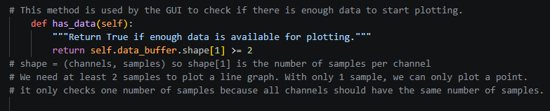
- Def has_data(self)

- Def get_window(self):
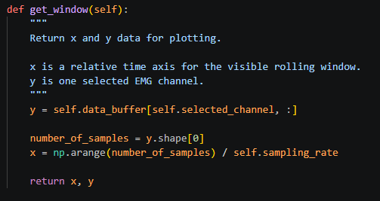
  - y = self.data_buffer[self.selected_channel, :]:
Extracts one row (one channel) from the 2D buffer:
- Before the comma = row → “self.selected_channel” = pick one specific row
- After the comma = column →”:” = take all columns
So after picking one row, y is a 1D array where each element is one sample value -> EMG measurement: y = [0.12, -0.34, 0.56, -0.78, ...] ← voltage at that time
  - number_of_samples = y.shape[0]:
.shape describes the structure of the array -> tells the size f the dimension
y = [0.12, -0.34, 0.56, -0.78] # 4 values
y.shape # → (4,)
↑
"this array has 4 elements"
NOT what the values are, just how many
.shape describes the structure — how many rows, columns
len() length of the first dimension
  - x = np.arange(number_of_samples) / self.sampling_rate
goal: Creating time axis for plotting
-> y is determining the number of samples
-> convert sample indices in y to time values:
Initially, samples are identified only by indices: 0, 1, 2, 3, ...
These are not time values.
Using the sampling rate $f_{s}$, each index $n$is converted into its corresponding timestamp: $t_{n}=\frac{n}{f_{s}}$
Thus:
sample index → actual time
Example for $f_{s}=250$Hz:
Sample Index | Time
0 | 0.000 s
1 | 0.004 s
2 | 0.008 s
3 | 0.012 s

- Def get_signal_time_seconds(self):

